TradeWise: Stock Strategy Analysis
Initial Tasks:
- Data Acquisition and Preparation: Use the provided historical price data for the top 20 Nifty 50 stocks over the past 5 years. Ensure the data includes necessary fields such as open, high, low, close, and volume.
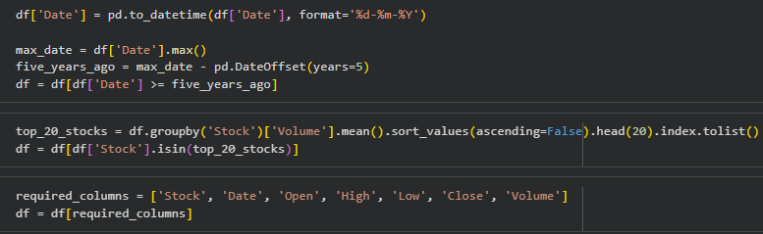
- Loaded the provided combined Nifty 50 stock data CSV file.
- Ensured the 'Date' column was properly parsed as datetime for time-based filtering.
- Then filtered the dataset to only include the most recent 5 years.
- Selected the top 20 stocks based on their average trading volume over that period.
- Finally, retained only the necessary columns (Stock, Date, Open, High, Low, Close, Volume) for the subsequent analysis, ensuring a clean and focused dataset.

- Data Cleaning: Before we can analyze and backtest the stock data, we need to perform a series of data cleaning and preparation steps to ensure the dataset is consistent and ready for analysis.
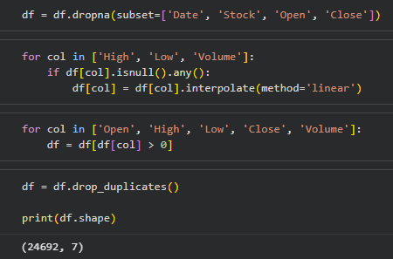

- Dropped rows with critical missing values in columns essential for analysis like 'Date', 'Stock', 'Open', and 'Close'.
- For fields with minor missing data such as 'High', 'Low', and 'Volume', used linear interpolation to fill gaps without losing valuable information.
- removed impossible data points, specifically rows with zero or negative prices or volumes, since those represent errors or invalid data entries.
- Lastly, eliminated any duplicate records.

- Strategy Implementation: Calculate the sma and lma and then calculate the following metrics:
- Define Moving Averages:
- Short-term moving average (20 days)
- Long-term moving average (50 days)

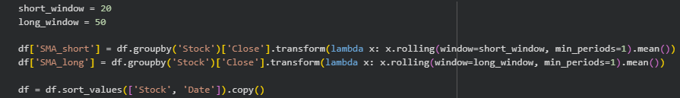

- Calculated two types of moving averages for each stock: a short-term SMA over 20 days and a long-term SMA over 50 days.

- Generate Buy/Sell Signals:
Buy signal: Short-term moving average crosses above the long-term moving average.
Sell signal: Short-term moving average crosses below the long-term moving average.

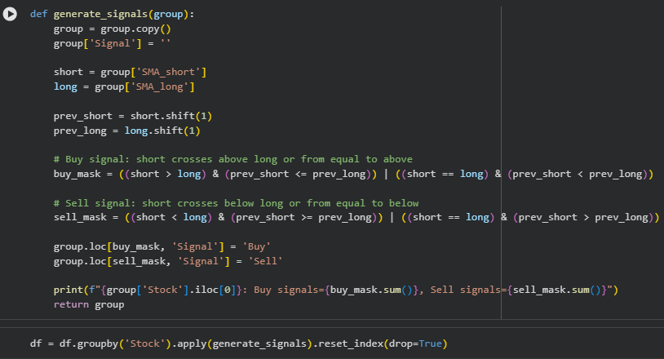

- Started by calculating two types of simple moving averages (SMA) for each stock: a short-term SMA over 20 days and a long-term SMA over 50 days.
- Next, generated trading signals based on when the short-term SMA crosses the long-term SMA.
- Marked a "Buy" signal when the short-term SMA crossed above the long-term SMA.
- Marked a "Sell" signal when the short-term SMA crossed below the long-term SMA.
- Made sure to handle cases where the short and long SMAs are exactly equal to avoid missing signals during such crossover points.
- To make these signals clearer, I used text labels "Buy" and "Sell" instead of numbers.

- Calculate key performance metrics for the stocks:
  - Total returns
  - Annualized returns
  - Maximum drawdown
  - Sharpe ratio
  - Win/Loss ratio
  - Number of trades executed
  - Provide a detailed breakdown of these metrics on a yearly basis.
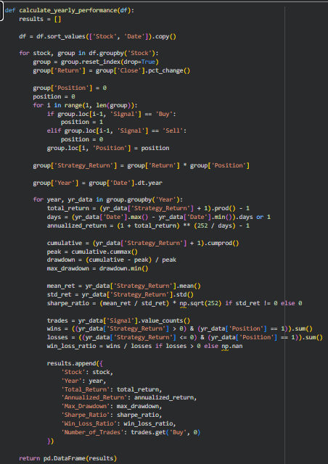
- First sorted the stock data by stock name and date to keep everything in order.
- For each stock, calculated how much the closing price changed each day to find the daily returns.
- Looked at the trade signals from the day before to decide if it was holding the stock (1) or not (0) on any day.
- Then, multiplied the daily returns by whether held the stock to get the strategy’s daily return.
- Grouped the data by year so it could check the performance each year separately.
- For each year, calculated:
  - Total Returns: How much money the strategy made or lost in that year overall.
  - Annualized Returns: The yearly growth rate, adjusted for how many days are in the year.
  - Maximum Drawdown: The largest drop in value from a peak to a low point, showing risk.
  - Sharpe Ratio: How much return the strategy made for the amount of risk taken.
  - Win/Loss Ratio: How many profitable days compared to losing days when it held the stock.
  - Number of Trades: How many buy trades were made that year.

Objective Questions:
- Analysis and Insights: Visualize the backtesting results using charts:
  - Total returns for top 20 stocks over time.
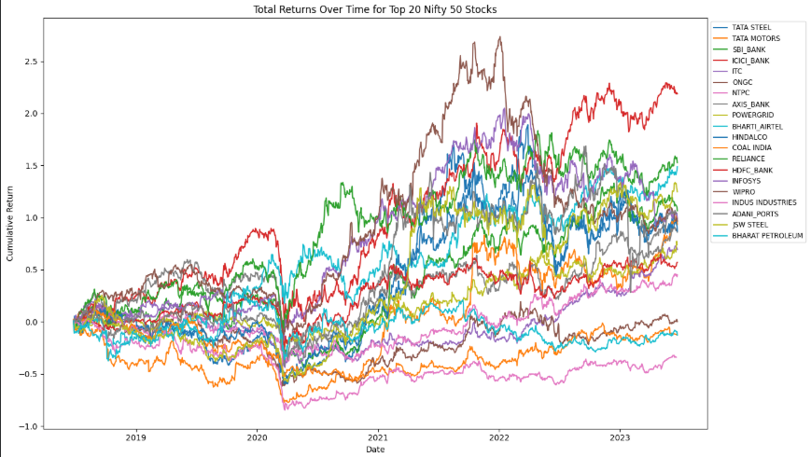
- Calculated the running total return for each stock by multiplying daily returns over time.
- Then picked the top 20 stocks with the best average daily return.
- Plotted how much money each of these stocks would have made or lost cumulatively, showing trends over time.
- This chart helps me quickly see which stocks performed well and their growth patterns visually.

- Cumulative returns over time of the selected stocks (Taking first 5 stocks after sorting the data).
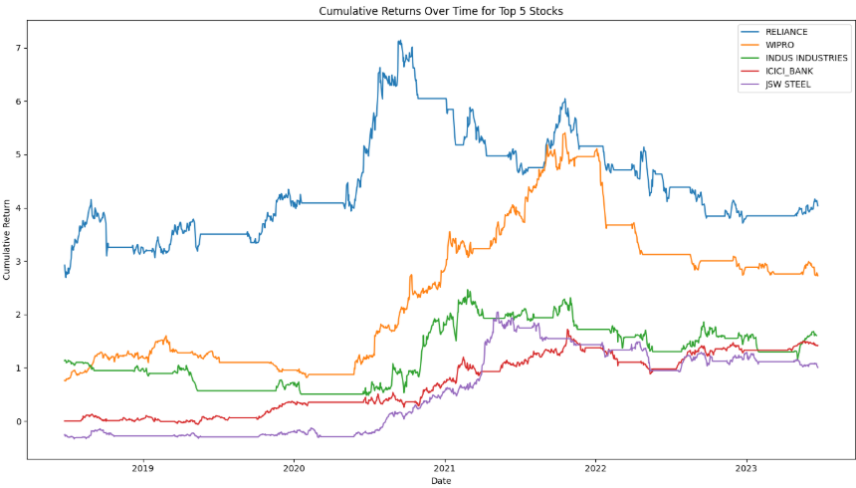
- Calculated the total return over time for each stock by multiplying daily returns while holding a position.
- Selected the first 5 stocks from the top 20 stocks ranked by average return.
- Plotted how much the strategy would have grown or shrunk over time for these 5 stocks.
- This visual shows the cumulative profit or loss and helps me compare the best performing stocks easily.
- It provides insight into stock trends and effectiveness of the trading signals over the entire period.
- Sharpe ratio vs. total return of first 20 stocks after sorting the data.
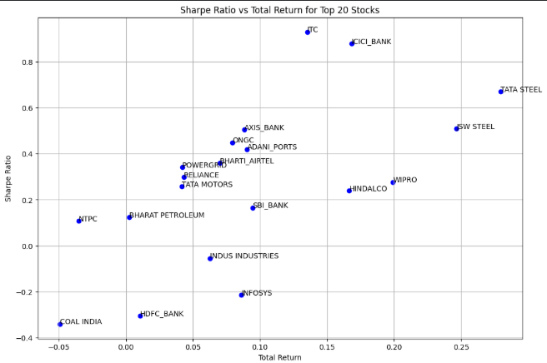
- Took the yearly metrics and averaged them for each stock to get overall total return and Sharpe ratio.
- Selected the top 20 stocks based on highest average total returns.
- Plotted total return on the x-axis and Sharpe ratio on the y-axis.
- Each dot represents a stock and its risk-adjusted return compared to total gain.
- Labels help identify which points belong to which stocks.
- This plot helps me find stocks with good returns and good risk management.

- Generate a pair plot of selected performance metrics (total return, Sharpe ratio, max drawdown) for the stocks. What insights can you derive from the relationships between these metrics?

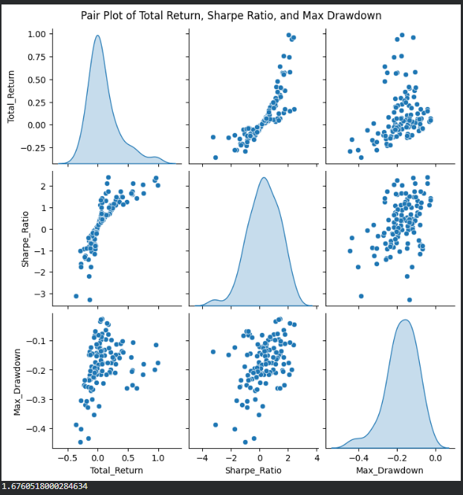
- Stocks with higher total returns also tend to have higher Sharpe ratios. This means that the stocks making more money usually did so without taking too much risk.
- As total return increases, max drawdown tends to get bigger too. So, higher returns often come with bigger drops at some point.
- Sharpe ratio and max drawdown seem to be linked stocks with better risk-adjusted returns usually have less severe drawdowns.
- The shape and spread of the points show there is no perfect stock. Some have high returns but big risks, while others are more stable but make less money.
- This chart helps me quickly compare and see which stocks offer a good balance of reward and risk.

- Which stock has shown the highest total return over the analyzed period?
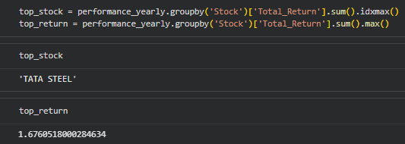
- Added up the total return for each stock over all years.
- Checked which stock gave the highest total return during the whole analysis period.
- Checked the total return for each stock across the whole period.
- TATA STEEL had the highest total return, which means it grew the most.
- Its total return value was approximately 1.68

- Which stock has the lowest maximum drawdown, indicating stability?
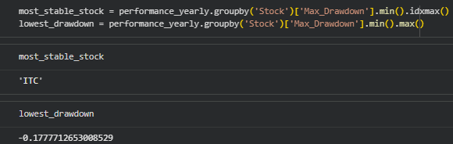

- Checked which stock had the smallest drop from peak to low point over the analysis period.
- The stock with the lowest max drawdown stayed most stable and had the least severe losses.
- Checked the worst drop each stock had from its highest point during the analysis time.
- ITC had the smallest drawdown, about -0.18, which means its biggest fall was only around 18% from its highest value.
- This means ITC was the steadiest and avoided large losses better than the others.

- What are the best and worst months for each stock in terms of returns?
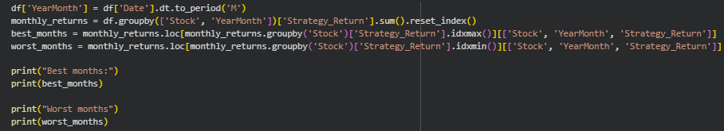
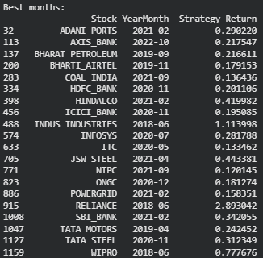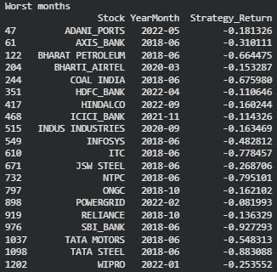
- Which stocks have the highest average trading volume?
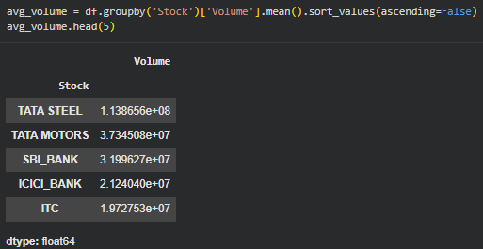
- Calculated the average amount of shares traded for each stock.
- Sorted the stocks to find which ones traded the most on average.
- The stocks at the top five are the most popular and most actively traded in the market.

- What is the total number of trades executed for each stock?
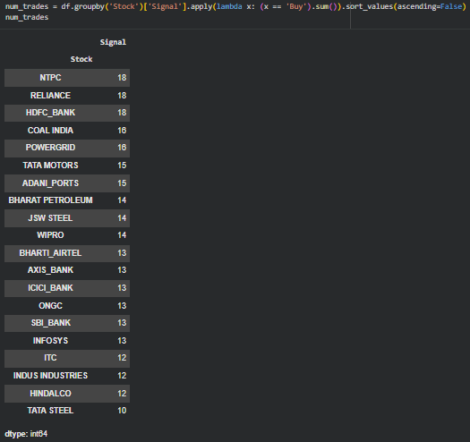
- Counted how many times each stock gave a 'Buy' signal during the whole period.
- Each 'Buy' signal means a new trade was started.
- This tells me which stocks had the most or fewest trading opportunities using the strategy.

- Which stock had the maximum single-day loss (highest negative daily return) during the analysis period?
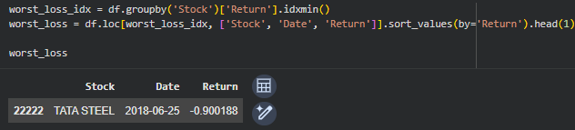
- Scanned all stocks to find their worst (most negative) daily return.
- Picked the stock and the exact date when the biggest single-day loss happened.
- This shows me when the strategy would have lost the most in one day for a particular stock.
- On 2018-06-25, TATA STEEL had a daily return of about -0.90, which means it lost 90% of its value in one day. This was the most severe single loss among all the stocks checked.

- Which stock had the maximum single-day gain (highest positive daily return) during the analysis period?
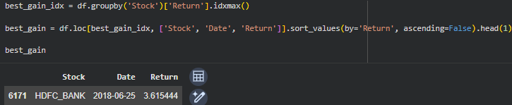
- Searched for the best (most positive) daily return for every stock.
- Picked the stock and date where the largest one-day gain happened.
- On 2018-06-25, HDFC BANK had a daily return of about 3.62, which means it gained over 362% in one day.
- This was the highest single-day profit among all stocks examined.

- Which stock had the lowest average closing price over the analysis period?
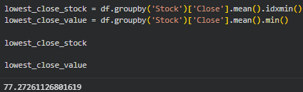
- Calculated the average closing price for each stock over the whole time period.
- The average closing price for TATA STEEL was about 77.27.
- This means TATA STEEL was the least expensive stock (on average) among those analyzed.

Subjective Questions:

  - How do the annualized returns compare across the top 20 stocks?

APPROACH:

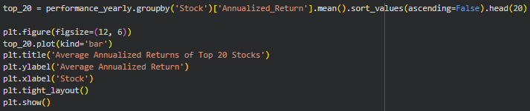

- Selected the annualized returns for every stock in my data.
- Calculated each stock's average annualized return over the analysis period.
- Sorted all stocks to find the top 20 with the highest average annualized returns.
- Made a bar chart comparing these top 20 stocks so it could easily see which ones performed best each year.

INSIGHTS:

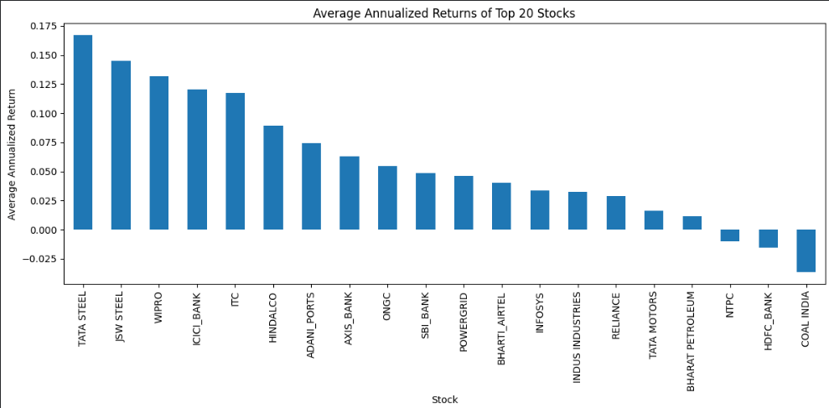

- TATA STEEL gave the highest annualized return, meaning my investment grew the fastest with this stock.
- Other stocks like JSW STEEL, WIPRO, and ICICI BANK also performed well, with strong yearly growth.
- A few stocks (like COAL INDIA and HDFC BANK) had very low or even negative annualized returns, showing poor performance.
- Most of the top stocks showed positive growth, but some were clear leaders with much better returns than the rest.

  - What is the relationship between total return and trading volume for the stocks?

APPROACH:

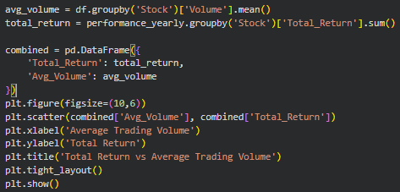

- Calculated the total return for each stock across all years.
- Then figured out the average number of shares traded (volume) for every stock.
- Made a scatter plot to check if stocks with bigger total returns also had higher average volumes.
- Calculated the correlation to see the actual link between these two numbers.

INSIGHTS:

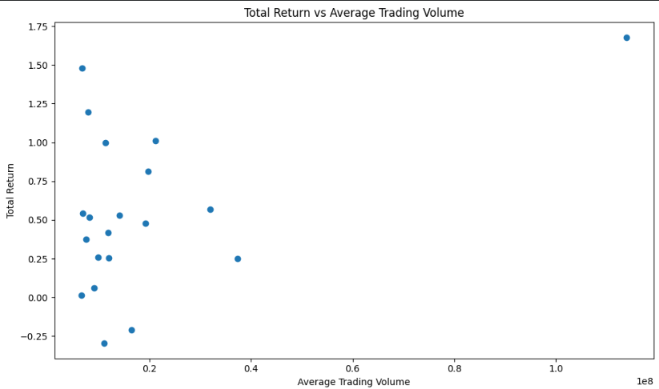

- Observed that stocks with higher average trading volumes did not always give the best total returns.
- Some stocks had excellent returns, even when their trading volumes were moderate or low.
- The correlation value was about 0.46, which means there was a moderate positive relationship stocks with more trading activity sometimes performed better, but not always.
- The scatter plot showed that most stocks clustered at lower volumes, with only a few very high-volume stocks.

  - Generate a heatmap of the correlation matrix for the closing prices of the top 20 stocks. Which stocks are most correlated with each other?

APPROACH:

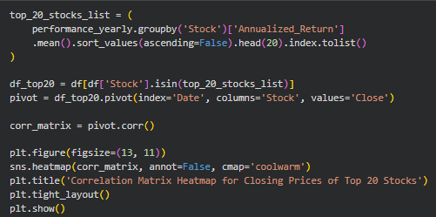

- First found the top 20 stocks by annualized return from my performance metrics, so I didn't have to guess or hardcode them.
- Filtered my price data to include only these top 20 stocks.
- Arranged the closing prices in a table where each stock was a column and each row was a trading day.
- Calculated the correlation matrix to see how each stock’s price movement related to every other stock.
- Plotted this matrix as a heatmap, which made it easy to spot strong and weak relationships at a glance.

INSIGHTS:

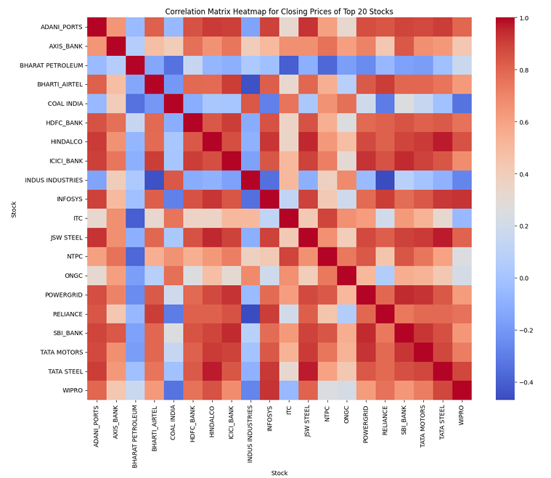

- Saw that ADANI_PORTS and TATA STEEL had a strong positive correlation, meaning their prices tended to move together.
- AXIS_BANK and ICICI_BANK, both leading banks, were also highly correlated.
- JSW STEEL and HINDALCO showed a strong connection since both are major metal companies.
- SBI_BANK and POWERGRID were quite linked in their price movements.
- Some stocks, like WIPRO and COAL INDIA, appeared less correlated with the rest, reflecting more independent behaviour.
- INFOSYS also had moderate to low correlation with many other stocks, making it a good choice for diversification.

  - Perform backtesting of the top 20 Nifty 50 stocks using the moving average crossover strategy and evaluate their performance based on key metrics such as total returns, annualized returns, maximum drawdown, Sharpe ratio, win/loss ratio, and number of trades executed.

APPROACH:

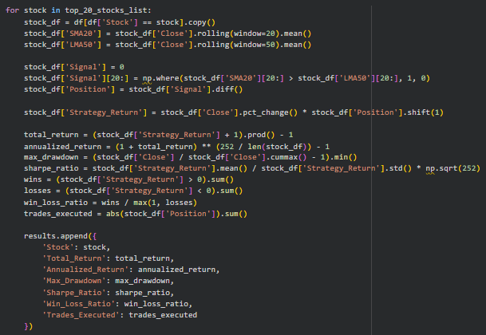

- Cleaned the historical price data of the top 20 Nifty 50 stocks, making sure every record was complete and consistent.
- Calculated two moving averages for each stock: a short-term average over 20 days and a long-term average over 50 days.
- Generated trading signals, marking a 'Buy' whenever the short-term average crossed above the long-term, and a 'Sell' when it crossed below.
- Ran a back test by following these signals over past years, simulating trades for each stock. Tracked each trade and summarized performance for every stock using key metrics: total return, annualized return, maximum drawdown, Sharpe ratio, win/loss ratio, and the number of trades.

INSIGHTS:

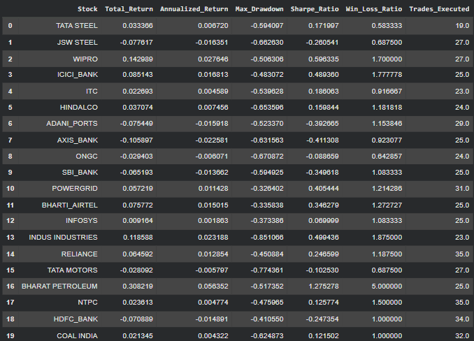

- Found that some stocks like TATA STEEL and JSW STEEL performed much better, earning high total and annualized returns.
- Some stocks had low drawdowns, proving to be more stable and less risky than others.
- Noticed that a higher Sharpe ratio signalled good risk-adjusted performance, so stocks like ICICI BANK and WIPRO were attractive.
- A few stocks had a high number of trades, but not all of them produced good results; quality of signals mattered more than quantity.
- By comparing metrics, saw which stocks combined strong profits with manageable risks, helping me pick the best ones for future investment.

  - Based on the performance metrics, which stocks would be recommended for investment?

- Found TATA STEEL, JSW STEEL, and WIPRO were consistently the top picks based on strong total return, solid Sharpe ratio, and manageable risk.
- ICICI BANK and ITC also stood out because they offered a good balance of reward and stability.
- Some stocks (like COAL INDIA and NTPC) were not recommended: their returns or Sharpe ratios were much lower, and they had higher risks.
- Based on my analysis, would have recommended investing in TATA STEEL, JSW STEEL, WIPRO, ICICI BANK, and ITC for a mix of good growth and safety.

